

**Software for Mobile Devices**

**Presentation Title**

GITHUB DEMO BY COMMAND LINE

**Group Members**

17L-4351 M Saad Sarfraz

17L-4130 M Zarar Tariq

17L-4181 Junaid Saleem

17L-4147 Iffat Kalsoom

FALL 2019

http://isb.nu.edu.pk/nusite/images/ohcd/fast_logo.png

**GITHUB DEMO BY COMMAND LINE**

**Commands:**

* git –version : Use to check current git version



* git config –global : use to add current username and password

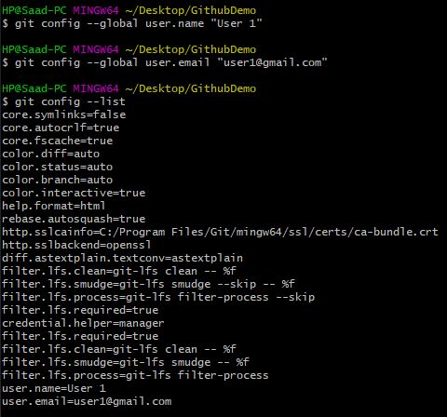

* git init : use to initialize empty git repository



* git status : use to check current status of files in current folder whether the files are added in the local repository or not

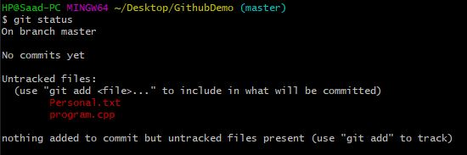

* touch filename : use to create new file

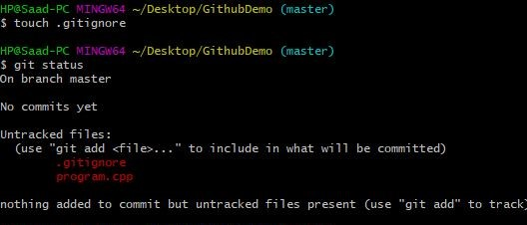

* git add filename : use to add files to local repository

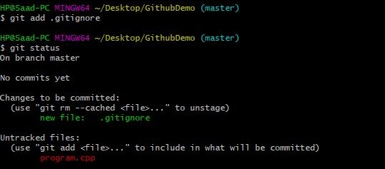

* git add –A : use to add all the untracked files into local repository

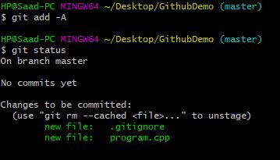

* git reset : use to remove all files from the local repository

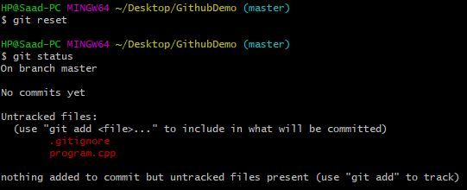

* git reset filename : use to remove specific file from local repository

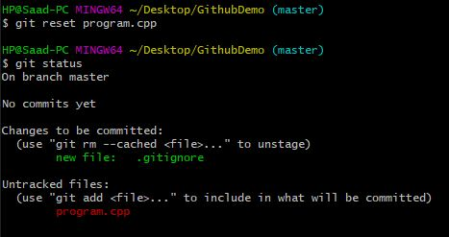

* git commit –m “comments” : use to commit the added files to push onto remote repository

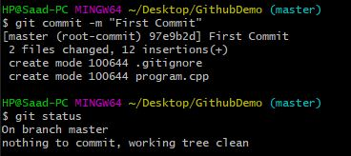

* git log : use to track record of all commits to the repository

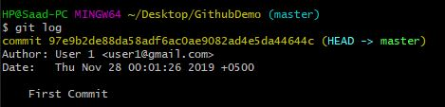

* git remote add origin ‘url of remote repository’
* git push –f origin master : use to force push all the files in local repository to remote repository

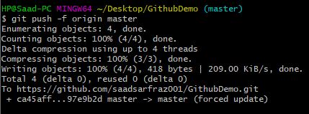

* git branch –a : use to check status of all the current branches

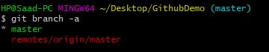

* git branch newBranchName : use to create new branch

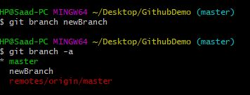

* git checkout branchname : use to switch to the new branch

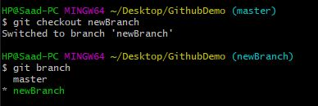

* git diff : use to check the changings made in the last added files

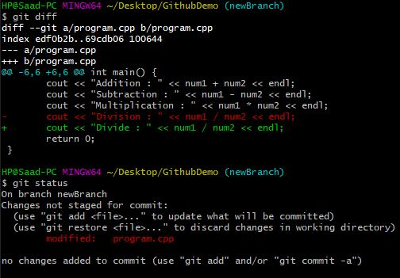

* git push –u origin newBranchName : use to push the untracked files to the new branch

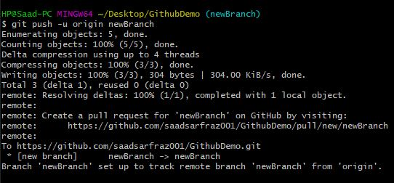

* git pull origin master : use to pull request the newly created branch to the master branch
* git branch –merged : use to check merged branches
* git merge newBranchName : use to merge new branch with the master branch
* git push origin master : use to push the files to the remote repository

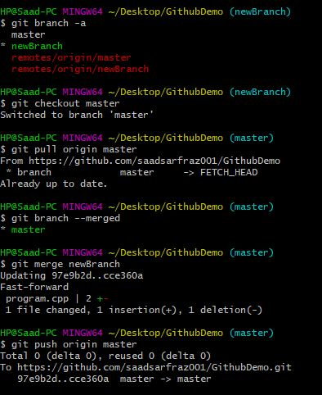

* git branch –d newBranchName : use to delete the bew branch from local repository
* git push origin –delete newBranchName : use to delete new branch from remote repository

